**PAF-Karachi Institute of Economics & Technology**

**(The Center of Excellence)**

**College of Computing and Information Sciences**

**Course Project Proposal Form**

|  |  |  |  |
| --- | --- | --- | --- |
| ***Sno.*** | ***Stud. ID*** | ***Names*** | ***Course Name/CID*** |
| 1 | 12113 | Shahmeer khan | 104910 |
| 2 | 12104 | Safi uddin |
| 3 | 12112 | M. Munim Qureshi |

**Project Title: Website:-** Discoveries.

1. Motivation:

The main purpose of choosing this topic is; we can get a lot of detail which would help us make our website much more dynamic and add some of the features we couldn’t really add with other topics. More over, It’s a topic we relate with our everyday life and we thought it was healthy to try to make something we use in our daily lives so we could also share our experience too.

1. Functional Features

Functional features for our project will be really basic that all the Information on some discoveries topics on our website in an article form with a lot of attractive layout and it being user friendly.

* Start with the most significant feature.

Description of each given topic in that website.

* Second most significant feature.

Different tabs for different series of other topics.

* More Addons:
* Multiple Pages connected with each other.
* YouTube video for more enhance description of each topic.
* User friendly using html/css.

1. Project Planning

We like to take things step by step and see what we can do to help make our project stand out. With that being said, we might be adding some personalized logo designs to make it unique as well.

**OUTPUT SCREENSHOTS:**

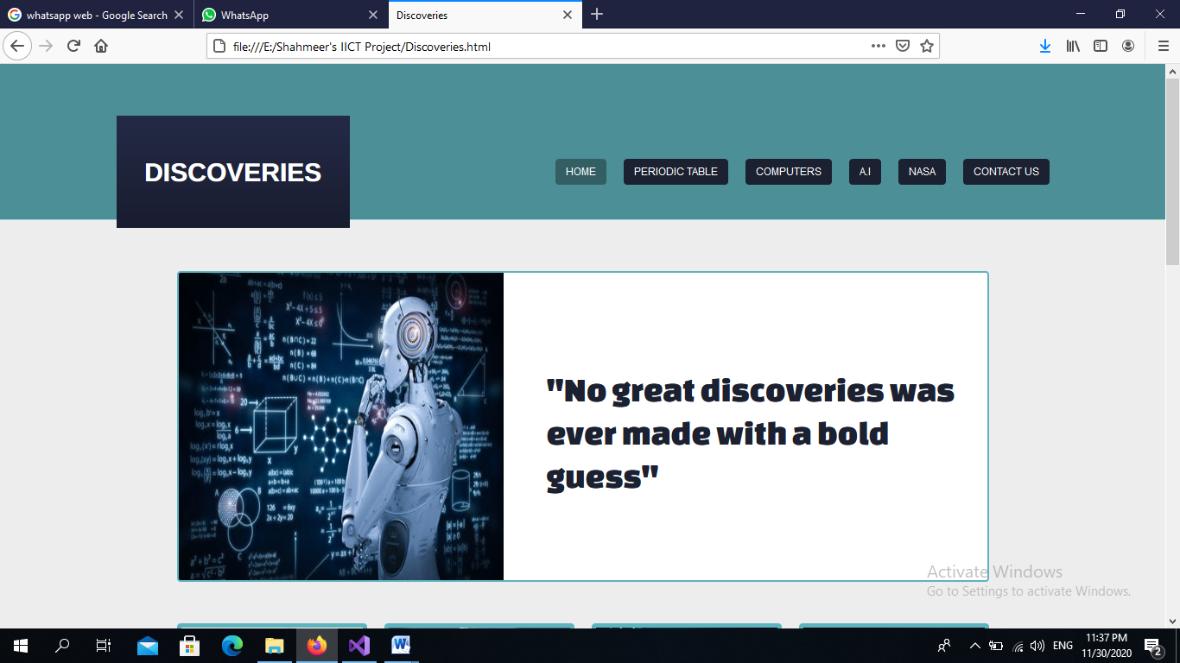

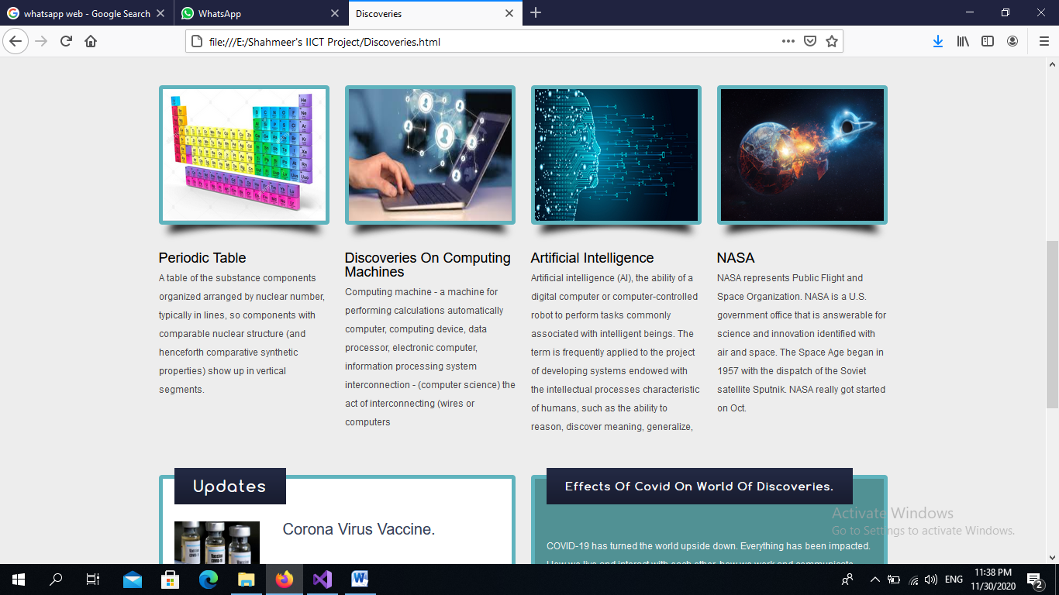

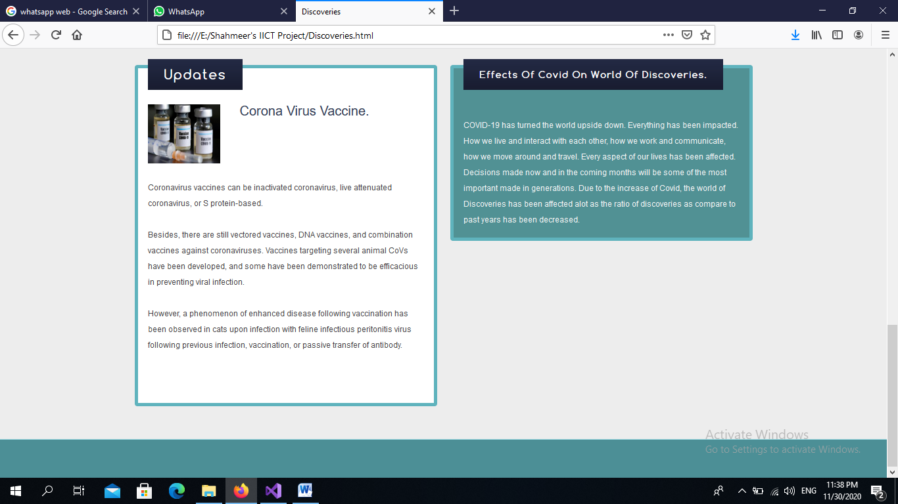

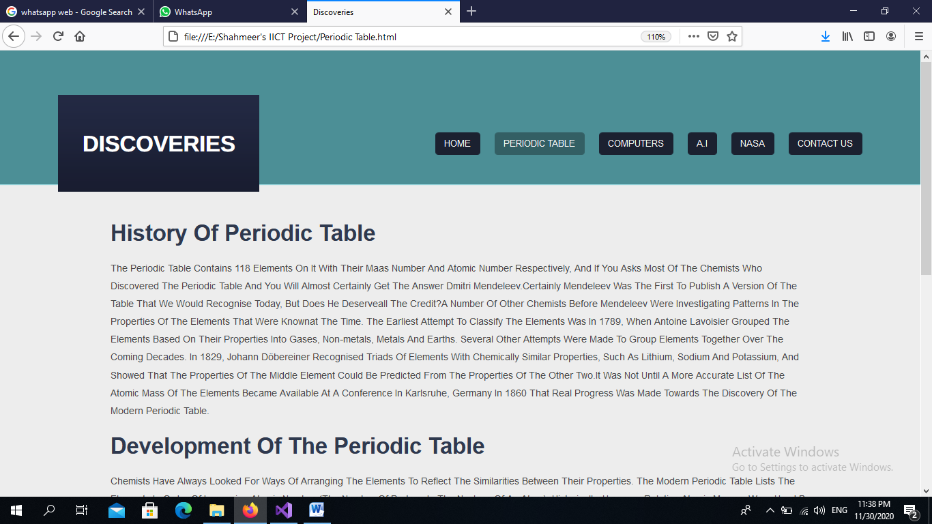

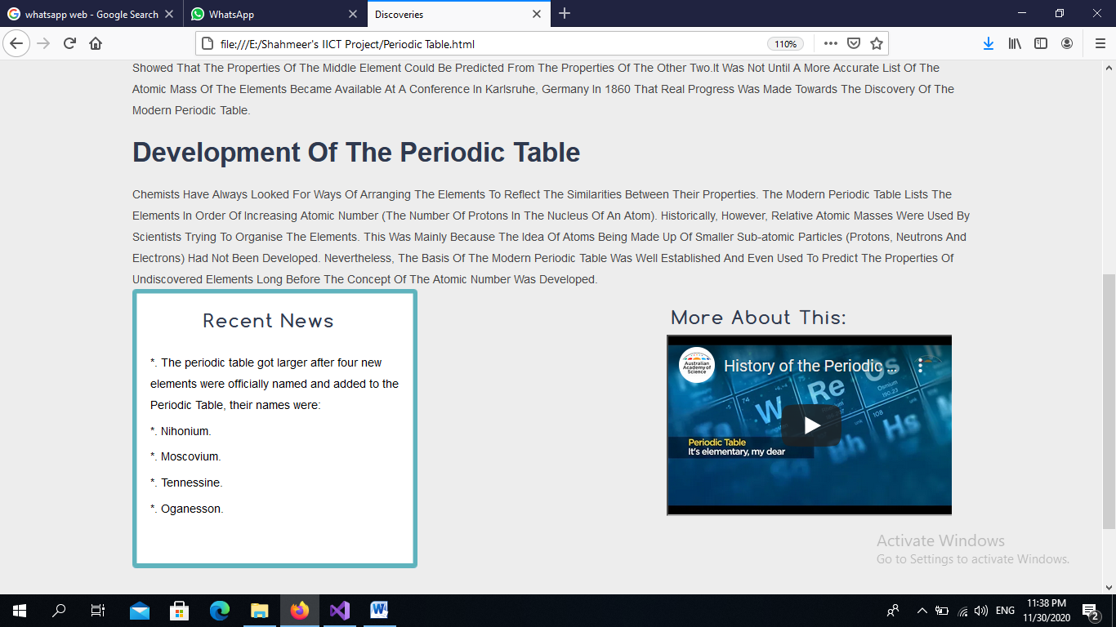

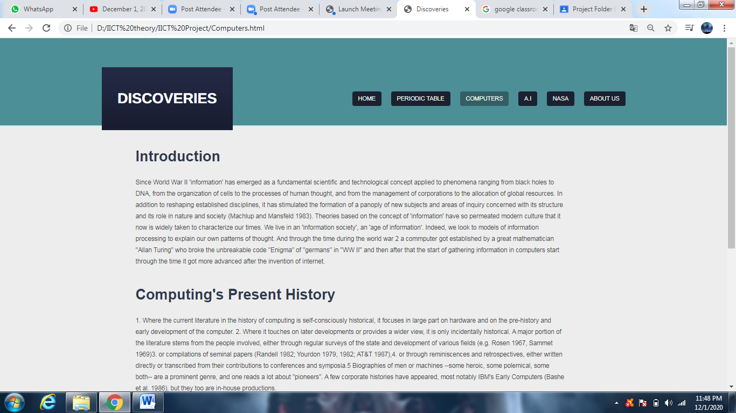

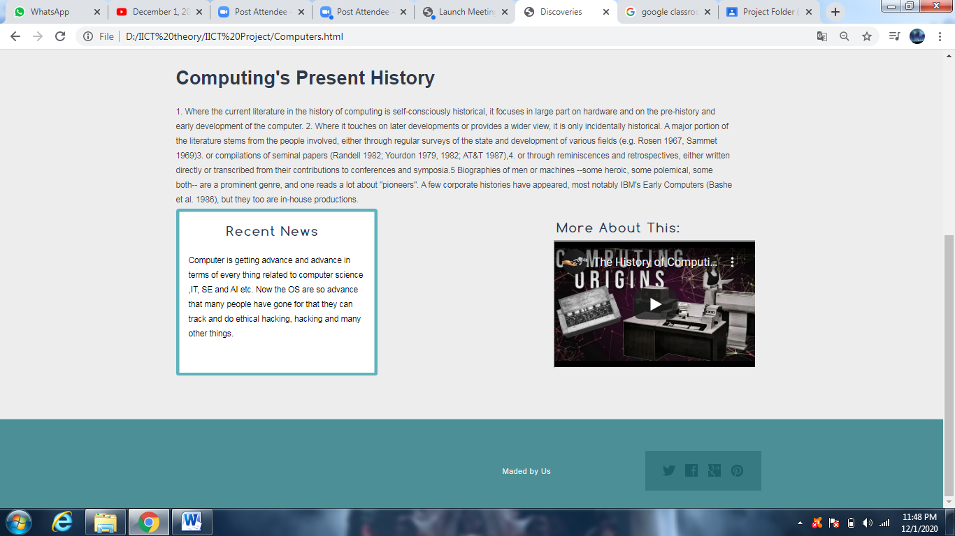

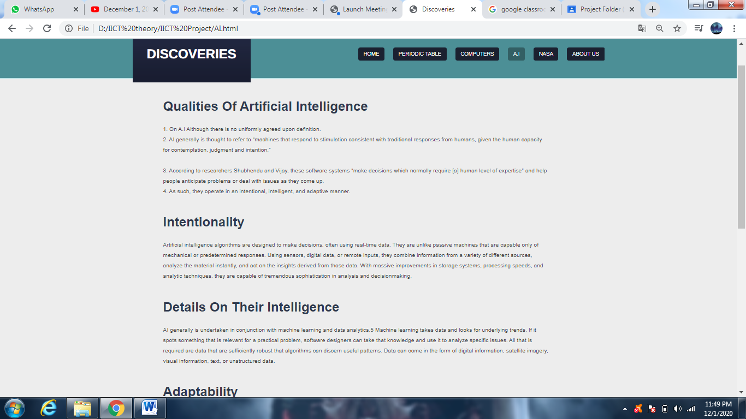

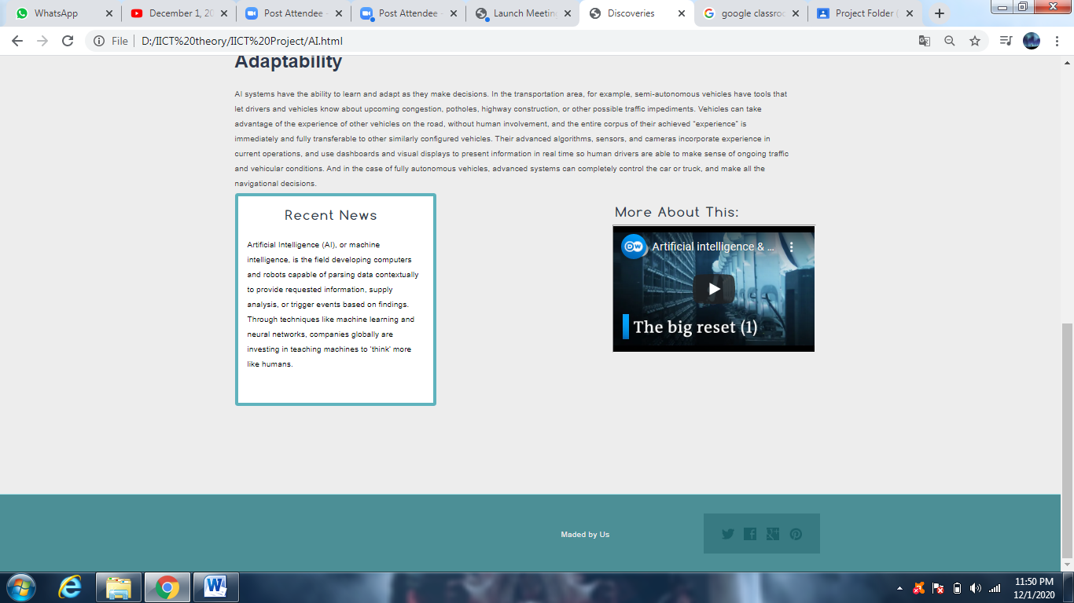

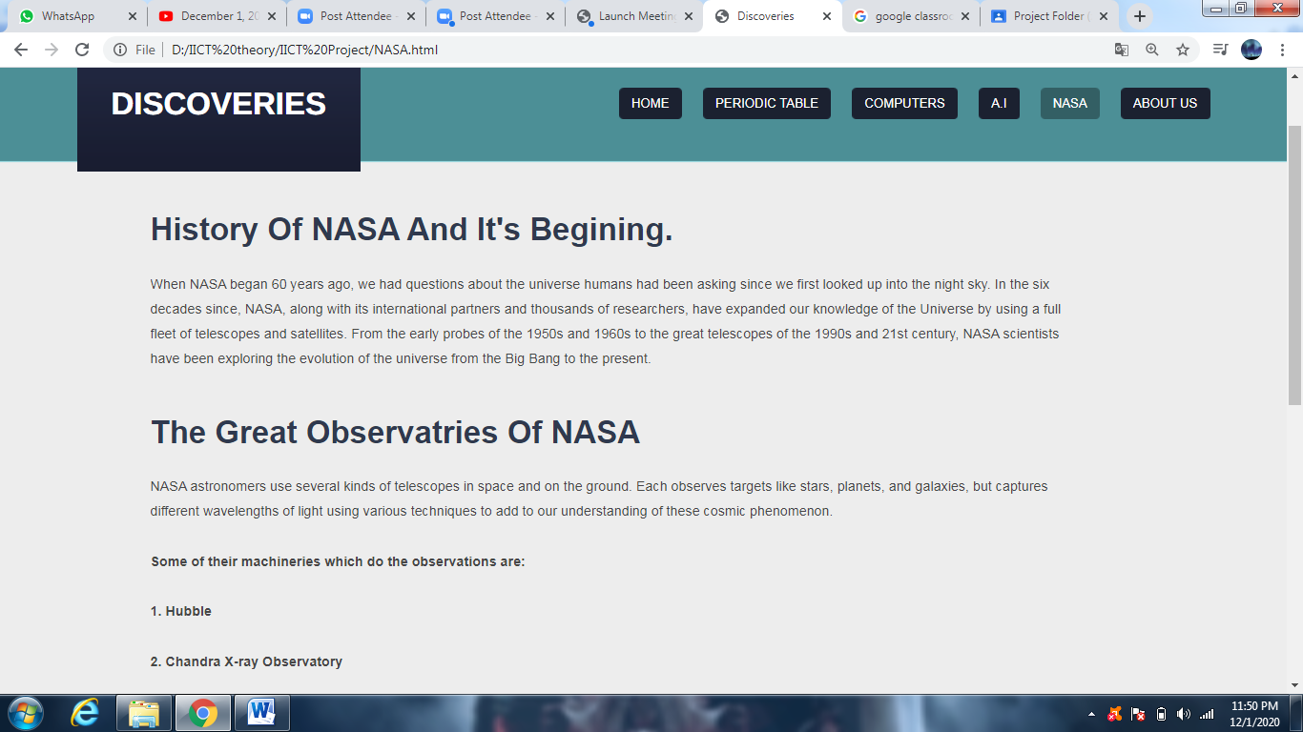

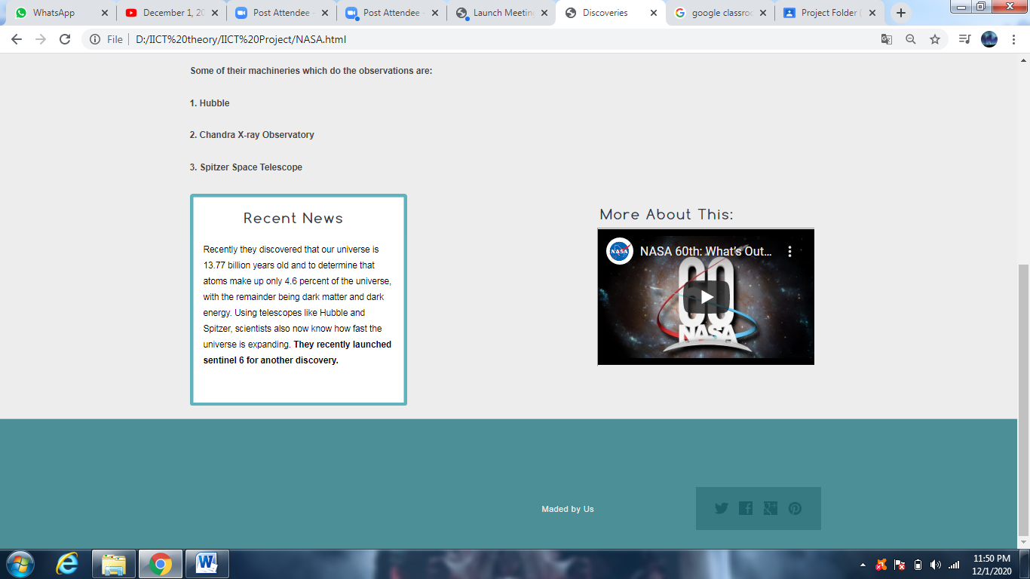

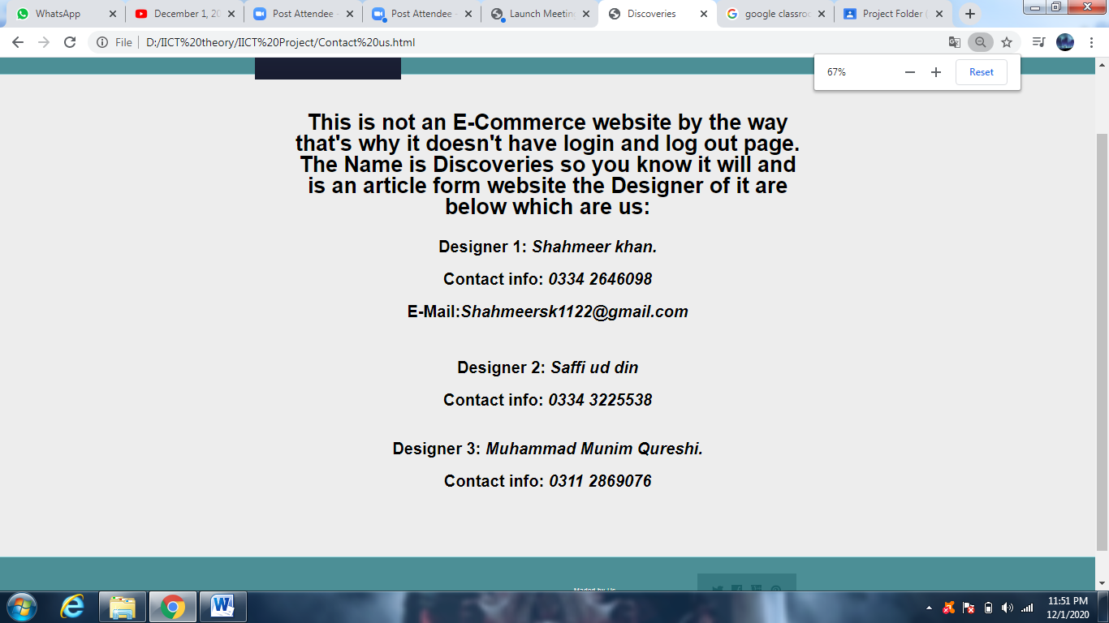

In this project(Website) we have presented 5 different topics upon dicoveries , we are representing History and discovery related topics on Periodic Table , Computing Machines , A.I , Nasa last but not the least we have provided button of contact us in which all the details of the designers are been provided , all the buttons are linked with eachother a future advance we have connected pictures working as a button form on most of the main pages and all the pages settled on each page with the tag of <div>. No hard coding is done use of simple tags in the code has been done.